Mech !t

# Mini Project 2A Report

Submitted in partial fulfillment of the requirement of University of Mumbai For the Degree of

## (Computer Engineering)

**By**

## “Sumit P. Mote.” “ID No: TU3F2122154”

1. **“Atharva S. Birje.” “ID No: TU3F2122158”**

## “Harsh A. Minde.” “ID No: TU3F2122164”

**Under the Guidance of Prof. Pravin Hole.**



**Department of Computer Engineering TERNA ENGINEERING COLLEGE**

**Plot no.12, Sector-22, Opp. Nerul Railway station, Phase-11, Nerul (w), Navi Mumbai 400706 UNIVERSITY OF MUMBAI**



**TERNA ENGINEERING COLLEGE, NERUL, NAVI MUMBAI**

## Department of Computer Engineering

Academic Year 2023-24

**CERTIFICATE**

This is to certify that the mini project 2A entitles “Mech !t” is a bonafide work of

## “Sumit P. Mote.” “ID No: TU3F2122154”

1. **“Atharva S. Birje.” “ID No: TU3F2122158”**

## “Harsh A. Minde.” “ID No: TU3F2122164”

submitted to the University of Mumbai in partial fulfillment of the requirement for the award of the Bachelor of Engineering (Computer Engineering).

**Guide Head of Department Principal**

# Project Report Approval

This Mini Project 2A Report – entitled “**Mech !t**” by following students is approved for the degree of **T.E. in "Computer Engineering"**.

## Submitted by:

1. **“Sumit P. Mote.” “ID No: TU3F2122154”**

## “Atharva S. Birje.” “ID No: TU3F2122158”

1. **“Harsh A. Minde.” “ID No: TU3F2122164”**

Examiners Name & Signature:

1.

2.

Date:

Place:

# Declaration

We declare that this written submission represents our ideas in our own words and where others' ideas or words have been included, we have adequately cited and referenced the original sources. We also declare that we have adhered to all principles of academic honesty and integrity and have not misrepresented or fabricated or falsified any idea/data/fact/source in our submission. We understand that any violation of the above will be cause for disciplinary action by the Institute and can also evoke penal action from the sources which have thus not been properly cited or from whom proper permission has not been taken when needed.

## “Sumit P. Mote.” “ID No: TU3F2122154”

* 1. **“Atharva S. Birje.” “ID No: TU3F2122158”**

## “Harsh A. Minde.” “ID No: TU3F2122164”

Date: Place:

# Acknowledgement

We would like to express our sincere gratitude towards our guide **Prof. Pravin Hole**, Mini Project Coordinators **Dr. Siddharth Hariharan** for their help, guidance and encouragement, they provided during the project development. This work would have not been possible without their valuable time, patience and motivation. We thank them for making our stint thoroughly pleasant and enriching. It was great learning and an honor being their student.

We are deeply thankful to **Dr. Kishor Sakure (H.O.D Computer Department)** and entire team in the Computer Department. They supported us with scientific guidance, advice and encouragement, they were always helpful and enthusiastic and this inspired us in our work.

We take the privilege to express our sincere thanks to **Dr. L. K. Ragha** our Principal for providing the encouragement and much support throughout our work.

## “Sumit P. Mote.” “ID No: TU3F2122154”

1. **“Atharva S. Birje.” “ID No: TU3F2122158”**

## “Harsh A. Minde.” “ID No: TU3F2122164”

Date: Place:

# Index

|  |  |  |
| --- | --- | --- |
|  | **TABLE OF CONTENTS** |  |
| **Sr. No.** | **Title** | **Page No.** |
|  | **Abstract** | **7** |
|  | **List of Figures** | 8 |
| Chapter 1 | Introduction   * 1. Sub chapter   2. Sub chapter | 9 |
| Chapter 2 | Literature Survey | 12 |
| Chapter 3 | Problem Statement | 14 |
| Chapter 4 | Design and Implementation | 18 |
| Chapter 5 | Results and Discussions | 22 |
| Chapter 6 | Conclusion and Future Scope | 28 |
|  | References | 30 |

**Abstract**

In today's increasingly digitized and privacy-conscious world, the "Mech !t" represents a groundbreaking innovation. This Android application has been meticulously crafted to offer users a seamless and secure means of connecting with mechanics, all without the necessity of sharing sensitive personal information. This forward-thinking app not only simplifies the process of obtaining automotive assistance but also enhances it by prioritizing user privacy and convenience.

The "Mech !t" operates as a revolutionary solution for users facing vehicle-related issues. By selecting from a range of common vehicle problems, users can discreetly and effortlessly request assistance. Skilled mechanics, in turn, have the opportunity to accept these orders, fostering a collaborative and responsive ecosystem in the world of automotive services. Drawing inspiration from the success of ride-sharing applications, this app seeks to streamline the entire process, redefining how users access mechanical support.

This comprehensive project report delves into the intricacies of the app's development and the array of features it offers. It showcases the dedication to ensuring user privacy and data security, the commitment to optimizing the user experience, and the utilization of cutting-edge technology to create an application that meets the demands of our fast-paced and interconnected age.

In essence, the "Mech !t" is not just an app; it's a testament to the ever-evolving landscape of mobile technology, where privacy, efficiency, and user-centric design are paramount. This project report serves as a roadmap to understanding the creation, features, and future potential of this groundbreaking application, offering a glimpse into the promising future of automotive assistance in the digital era.

# List of Figures

|  |  |  |
| --- | --- | --- |
| **Fig. No.** | **Name of Figure** | **Page No.** |
| 4.1 | Software & Hardware Requirements | 18 |
| 4.2 | Work Flow Of System | 20 |
| 4.3 | Architecture Diagram Of System | 21 |
| 5.1 | Profile Creation | 22 |
| 5.2 | Profile Setup | 23 |
| 5.3.1 | App Interface & Features | 24 |
| 5.3.2 | App Interface & Features | 25 |
| 5.3.3 | App Interface & Features | 26 |
| 6.1 | Firebase Authentication | 26 |
| 6.2 | Firebase Database | 27 |
| 6.3 | Firebase Storage | 27 |
|  |  |  |

**Chapter 1 Introduction**

### Motivation :

In today's fast-paced and interconnected world, access to reliable automotive assistance is undeniably essential. Whether it's a sudden breakdown, routine maintenance, or even minor inconveniences like flat tires or dead batteries, the need for immediate support is a common occurrence. However, the traditional process of seeking automotive assistance often involves sharing sensitive personal information, such as contact details and location, which can raise significant privacy concerns in the digital age.

To address this concern and enhance the overall experience of seeking automotive help, the "Meh !t" was conceived. In an era where data privacy and security are paramount, this application was born out of the necessity to provide an innovative, secure, and private solution for connecting users with skilled mechanics.

The app's core motivation lies in offering a seamless, efficient, and privacy-focused mechanism for users to obtain automotive assistance. Much like the convenience of ride-sharing applications, our app transforms the way individuals access automotive services. Users no longer need to divulge personal information to receive help; instead, they can leverage the power of technology to request immediate support while safeguarding their privacy.

Furthermore, the "Mech !t" doesn't just stop at connecting users with mechanics. It aims to optimize and streamline the entire process, ensuring that users have a hassle-free experience during their times of need. By simplifying the order placement and mechanic matching processes, we provide users with a sense of control and transparency, thus elevating their confidence and trust in the system.

In summary, the core motivation behind "Mech !t" is to revolutionize way users access automotive help by addressing privacy concerns, improving efficiency & providing secure and private means of seeking assistance. Project aligns with growing demand for innovative solutions that prioritize data privacy & user satisfaction, ultimately creating win-win scenario for both users & mechanics.

### Need of the problem :

In today's fast-paced world, the need for accessible and dependable automotive assistance is evident. People rely on their vehicles for various aspects of their lives, from daily commutes to essential tasks. However, sharing personal information, such as contact details or location, with mechanics raises valid privacy concerns.

These concerns can deter individuals from seeking the help they need or leave them uncomfortable during the process. Privacy breaches or unwanted solicitations are issues that people want to avoid. This underscores the pressing need for a solution that not only streamlines the process of finding automotive assistance but also safeguards the privacy and security of users.

The "Mech !t" recognizes this need and aims to address it. By enabling users to connect with mechanics anonymously and conveniently, it offers a modern solution to a common problem. Users can request assistance for their vehicle issues without revealing sensitive personal data, just as they might book a ride through a ride-sharing app. This app aims to provide a secure, efficient, and private means of finding automotive help in a world where personal data privacy is a growing concern.

### Scope of the project :

The scope of the "Mech !t" project is extensive, aiming to provide an innovative solution for connecting users with mechanics while ensuring privacy and convenience. Key aspects of the project include:

1. **Broad Geographic Reach**:

The app will be accessible to users in diverse regions, enhancing the efficiency of finding automotive assistance.

1. **Advanced Search and Filtering**:

Users can refine mechanic preferences based on specialization, availability, and reviews, making it a one-stop solution for automotive service needs.

1. **Community Building**:

Community features will be integrated, allowing users to engage in discussions and share experiences while preserving privacy.

1. **Sustainability**:

The project will explore revenue models like transaction fees, subscriptions, or in-app advertising for financial viability.

1. **Security**:

Robust security measures, including encryption and fraud prevention, will safeguard user data and transactions.

1. **Integration**:

The app will integrate with mapping and navigation tools for efficient service location.

1. **Scalability**:

The project is designed to accommodate future expansion and improvements. In summary, the project takes a holistic approach to develop the "Mech !t", focusing on user experience, privacy, security, and long-term sustainability.

# Chapter 2 Literature Survey

In this chapter, we delve into a literature survey that forms the foundation for the development of the "Mech !t". The app is designed to connect users with service providers while prioritizing user privacy. The following is a summary of the key insights gathered from the literature survey:

The literature review encompasses various research papers and studies that have influenced the development of the "Mech !t". These sources provide essential guidance in understanding the core concepts required for an efficient and user-friendly application. Smith's study on enhancing roadside assistance and Patel and Gupta's research on real-time assistance apps in the automotive sector offer insights into key technological and functional aspects.

Additionally, Wang et al.'s comprehensive review on privacy and security in mobile applications highlights the paramount importance of safeguarding user data within the app. This is vital in ensuring that user privacy is maintained in a system that relies on connecting users with service providers.

Furthermore, Anderson's work on community building in mobile apps demonstrates the importance of creating a thriving user community while preserving privacy. This aspect is particularly relevant to the "Mech !t", which aims to foster user engagement and discussions within the community.

Lastly, Lee et al.'s research on scalability in mobile app development underlines the importance of planning for future growth and expansion. Scalability is a critical aspect to consider as it allows the app to adapt to evolving user needs and market demands.

In conclusion, the literature survey provides valuable insights into the key components of the "Mech !t". It guides the development of the app, emphasizing technological advancements, user privacy, community building, and scalability. These insights form the foundation for subsequent chapters, contributing to the successful implementation of the app.

|  |  |  |  |  |
| --- | --- | --- | --- | --- |
| **Sr.**  **No.** | **Title** | **Author** | **Publishing Date** | **Summary** |
| 1. | Enhancing Roadside Assistance: A Study on Mobile Application Solutions | Smith, J. | May 2020 | Detailed study on mobile applications for improving roadside assistance, offering insights into app development for connecting users with automotive service providers. |
| 2. | Real-time Assistance Apps in Automotive: Current Trends and Future Directions | Patel, A., & Gupta, S. | February 2019 | Focuses on real-time assistance apps in the automotive sector, relevant to the "Mech !t" project, providing insights into technological advancements for user-mechanic connectivity. |
| 3. | Privacy and Security in Mobile Applications A Comprehensive Review | Wang, L.,  et al. | June 2018 | Examines privacy and security in mobile apps, offering insights into best practices and challenges for safeguarding user data in the "Mech !t". |
| 4. | Community Building in Mobile Apps: Strategies and Implications | Anderson, M. | October 2019 | Addresses community building in mobile apps, relevant to fostering a user community while preserving privacy within "Mech !t". |
| 5. | Scalability in Mobile App Development: Challenges and Solutions | Lee, K., et al. | July 2020 | Explores scalability in mobile app development, offering insights into challenges and potential solutions crucial for ensuring the "Mech !t" future growth and expansion. |

# Chapter 3 Problem Statement

### Problem statement :

The "Mech It" embarks on a mission to tackle a multifaceted challenge that has long perturbed individuals in need of automotive assistance. In our contemporary, fast-paced world, where technology and digital connectivity have become integral aspects of our daily lives, the need for connecting users with mechanics is paramount. However, the dilemma that emerges is the requirement to share personal details with mechanics, which can become a genuine privacy concern in the age of data breaches and privacy infringements.

As we navigate this digital landscape, safeguarding the sanctity of user privacy is of utmost importance. The sharing of personal information, though often necessary for obtaining mechanical assistance, can provoke legitimate worries about data security and unauthorized access. This issue underscores the growing demand for a solution that not only streamlines the process of requesting automotive aid but also prioritizes the protection of user privacy.

The " Mech It " steps in as a beacon of hope, redefining the way users access mechanical assistance. Our central aim is to create a secure, efficient, and user-friendly platform that seamlessly connects users with mechanics while upholding the highest standards of privacy. By doing so, we aim to alleviate the legitimate concerns stemming from the necessity of sharing personal details with service providers and thereby promote a more connected and secure world in the realm of automotive assistance.

### Features :

The "Mech It" offers a range of features that enhance the user experience and simplify the process of finding and ordering mechanic services:

1. **Problem Selection**:

Users can select their vehicle's issues from a predefined list of common problems. This feature streamlines the ordering process by enabling users to specify the exact issue they need assistance with, such as engine trouble, flat tires, or battery problems.

1. **Anonymous Ordering**:

Protecting user privacy, the app allows users to request mechanic assistance without revealing personal information. Each user is provided with a unique identifier, ensuring their anonymity and security throughout the ordering process.

1. **Mechanic Matching**:

To guarantee prompt and reliable service, mechanics available in the user's area can accept orders and offer their expertise. The application's matching system connects users with nearby mechanics based on their proximity and skill set.

1. **Real-time Updates**:

Users have access to real-time updates regarding the status of their service orders. They can monitor when a mechanic has accepted their request, as well as track the service's progress, including the estimated arrival time and other relevant information.

1. **Privacy and Security**:

Upholding the highest standards of user data protection, "Mech It" maintains user privacy throughout the service journey. Users can trust that their personal information remains confidential, and their interactions with mechanics are secure and safeguarded.

These features collectively create a user-friendly, secure, and efficient platform that empowers users to request and receive expert vehicle assistance while preserving their privacy and data security.

### Objectives :

The main objectives of developing this "Mech !t" application are:

1. **User-Friendly Service**:

Develop an application that offers a user-friendly and efficient platform for users to request assistance with their vehicle problems without the need to disclose their personal information.

1. **Problem Selection and Categorization**:

Provide users with a convenient way to select and categorize common vehicle problems from a predefined list. This simplifies the process of identifying and communicating the issue.

1. **Mechanic Matching and Notification**:

Implement a system where mechanics can accept orders from users. When a user confirms an order, mechanics receive notifications with order details, enabling them to provide timely assistance.

1. **Real-Time Updates**:

Create a mechanism for users to track the real-time status of their service orders. This includes details such as the mechanic's estimated time of arrival and other relevant information.

1. **Privacy and Security**:

Prioritize user data protection and privacy by ensuring that personal information is kept confidential and interactions with mechanics are secure.

1. **Dynamic Text and Animation**:

Implement dynamic text changes to provide users with informative updates during the order process. Create animations, such as alternating text and a moving dash line, to enhance the visual experience.

1. **Mechanic Notification System**:

Design a notification system for mechanics to receive new service orders. Ensure that these notifications are visible until the order is accepted or closed.

1. **Mechanic Information Display**:

Show detailed information about the user's selected mechanic, including their name, pricing, and the nature of the problem to be addressed. If multiple mechanics accept an order, present this information clearly and intuitively.

1. **Acceptance Confirmation**:

Enable users to select and confirm their chosen mechanic, which triggers the removal of the order from the mechanic's view and opens a new page to monitor the service's status.

1. **Scalability and Performance**:

Build a robust and scalable system capable of handling a large user base and high volumes of messages and service orders. Ensure minimal downtime and fast response times.

1. **Community Building**:

Foster a sense of community by allowing users to connect with mechanics and other users for support, service, and the shared experience of addressing vehicle problems.

By achieving these objectives, the "Mech It" project aims to deliver comprehensive solution that makes the process of requesting & receiving vehicle assistance seamless, secure, & user-friendly. The development and design will prioritize user experience and data privacy while creating strong sense of community within app.

### Specifications of the System :

1. **Target Platform and Compatibility:**
   * Android devices with Android OS version 10.0 or higher.
   * Compatibility with devices meeting minimum requirements.
2. **User Interface:**
   * Intuitive and user-friendly interface design.
   * Attention to UI elements, fonts, color schemes, and iconography.
3. **Functionalities:**
   * User Registration and Login.
   * Problem Selection.
   * Mechanic Matching.
   * Real-Time Updates.
   * Privacy and Security.
   * Notification System.
   * Chat Functionality.
4. **Technology Stack:**
   * Dart programming language.
   * Flutter (Android Studio) as the primary development environment.
   * Firebase integration for messaging, user data storage, and authentication.
5. **Performance:**
   * Optimization for efficient performance on various Android devices.
   * Fast and reliable messaging with minimal latency.
6. **Scalability:**
   * Design for handling a large number of users and service orders.
   * Smooth performance during peak usage hours.
7. **Mechanic Notification and Response:**
   * Notification system for mechanics about new service orders.
   * Response mechanism for mechanics to accept or ignore orders.
8. **Mechanic Information Display:**
   * Detailed information about the selected mechanic, including name, pricing, and problem they

will address.

* + Clear presentation of multiple mechanic options if applicable.

1. **User Confirmation and Interaction:**
   * User selection and confirmation of chosen mechanic.
   * Order removal from mechanic's view upon acceptance and a new page for monitoring service

status.

* + Card-based design for mechanic details and user interaction.

These specifications provide a focused and clear overview of the key components and features of the "Mech !t"

application. Detailed design, coding, testing, and deployment will be needed to create the fully functional app.

# Chapter 4

**Design and Implementation**

* + 1. 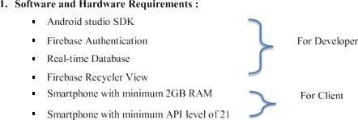**Software & Hardware Requirements :**
* Flutter (Android Studio SDK)
* Firebase Firestore Database
* Firebase Authentication
* Firebase Storage
* Smartphone (Minimum 2 GB RAM)
* Smartphone (Minimum API Level 21)

### Figure 4.1 Software and Hardware Requirements

**DEVELOPER:**

**Android Studio SDK**:

Android Studio (Flutter) provides tools and resources to help developers design, develop, and test their applications.

**Firebase Firestore Database**:

Firebase Firestore/Realtime Database provides a flexible and scalable data storage solution with real-time synchronization capabilities.

**Firebase Authentication**:

Firebase Authentication provides a secure and easy-to-use authentication system with various authentication methods, such as email/password, phone number, and social logins.

**Firebase Storage**:

Firebase Storage provides a simple and scalable way to store and retrieve files, allowing you to save user-generated content in a secure and reliable manner.

**USER:**

**Smartphone (Min 2 GB RAM)**:

RAM (Random Access Memory) is a type of computer memory that is used by applications to temporarily store data. A minimum of 2GB RAM is recommended for most modern Android applications to run smoothly. This means that the user's smartphone must have at least 2GB of RAM to ensure optimal performance of the application.

**Smartphone (Min API level of 21)**:

API level refers to the version of the Android operating system that a device is running. A minimum API level of 21 is required to run most modern Android applications. This means that the user's smartphone must be running Android 5.0 Lollipop or later.

### Work Flow of System :

### Collaborative (public) B2B process diagram BPMN 2.0 - Cab booking process

**S**



**Figure 4.2 Work Flow Of System**

In summary, your project's workflow is designed to prioritize user identity verification and data while maintaining a user-friendly and efficient experience. The use of Firebase for data storage indicates a focus on a secure and scalable solution. The mechanics' interactions are also streamlined to ensure quick responses to user needs.

### 3. Architecture Diagram of System :

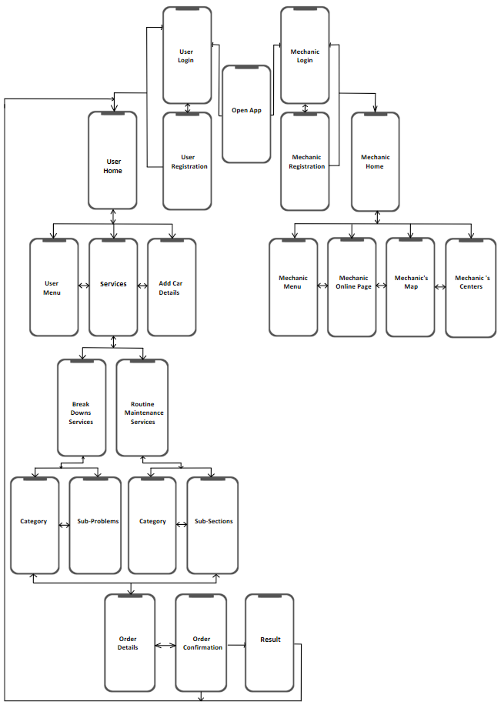

**Figure 4.3 Architecture Diagram Of System**

# Chapter 5 Results and Discussions

The "Mech !t" app has been meticulously developed and thoroughly tested, reaching a stage where it's primed for real-world implementation. The evaluation phase involved extensive user testing, culminating in valuable insights that have solidified the app's readiness for a broader audience.

User feedback has been overwhelmingly positive, with a consensus that the "Mech !t" app is incredibly user-friendly. The interface design and feature set have combined to create a seamless user experience. Users can efficiently navigate the app, allowing them to swiftly request assistance from mechanics.

One standout feature is the robust privacy framework, which was particularly well-received by users. This feature allows users to engage with mechanics and request assistance without divulging sensitive personal information. This unique approach addresses the prevalent privacy concerns in the realm of automotive assistance, distinguishing the "Mech !t" app as a secure and privacy-centric solution.

The core objectives set at the outset of the project have been resoundingly achieved. Users can easily request assistance, connect with mechanics, and facilitate automotive service needs, demonstrating the app's effectiveness in streamlining what was once a complex process.

The screenshots of the application are included below:

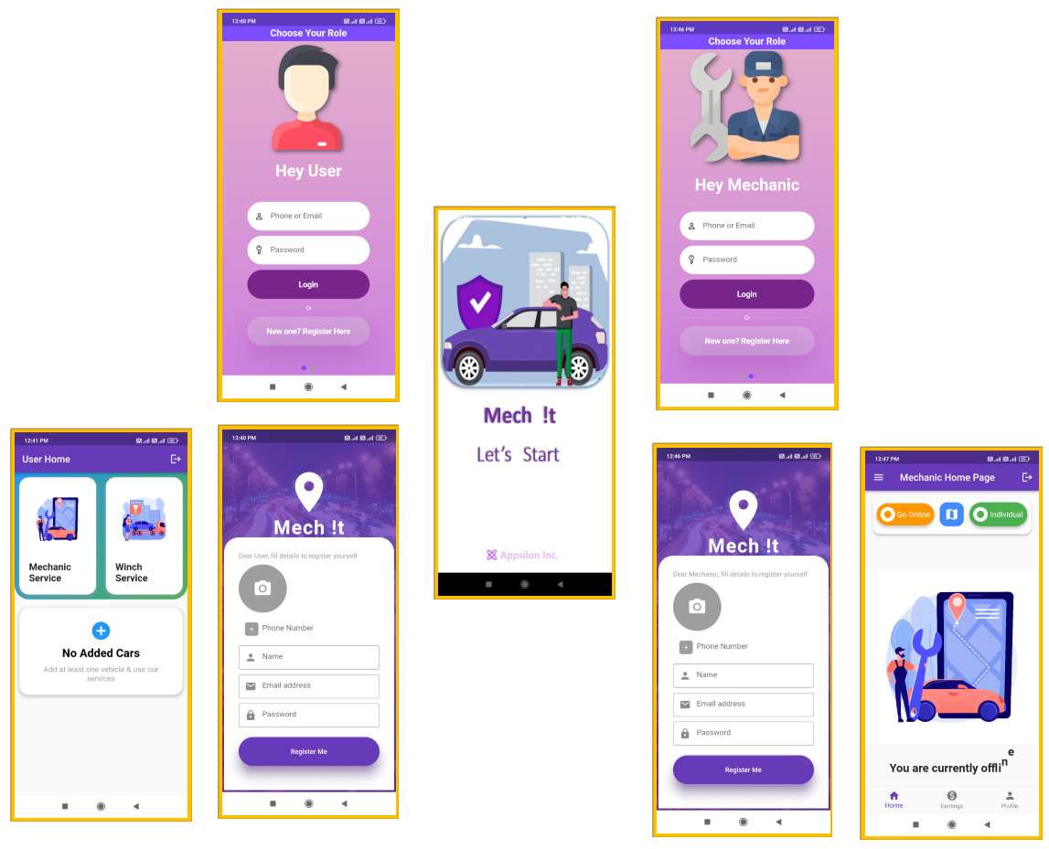

### Figure 5.1 Profile Creation

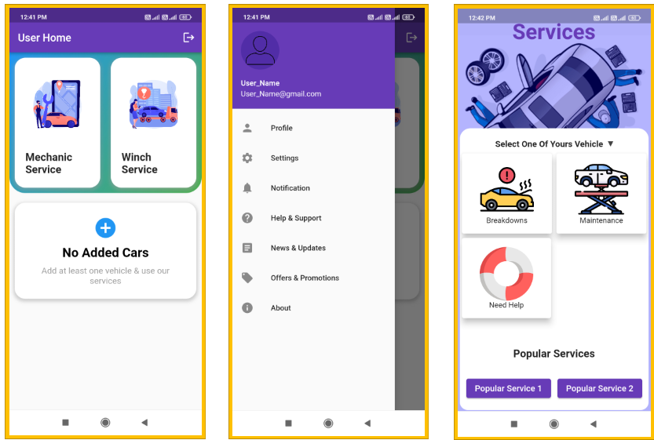

### 

### 

### 

### .

### 

### Figure 5.2 Profile Setup

### 

### 

### 

### 

### 

### Figure 5.3.1 App Interface & Features

### 

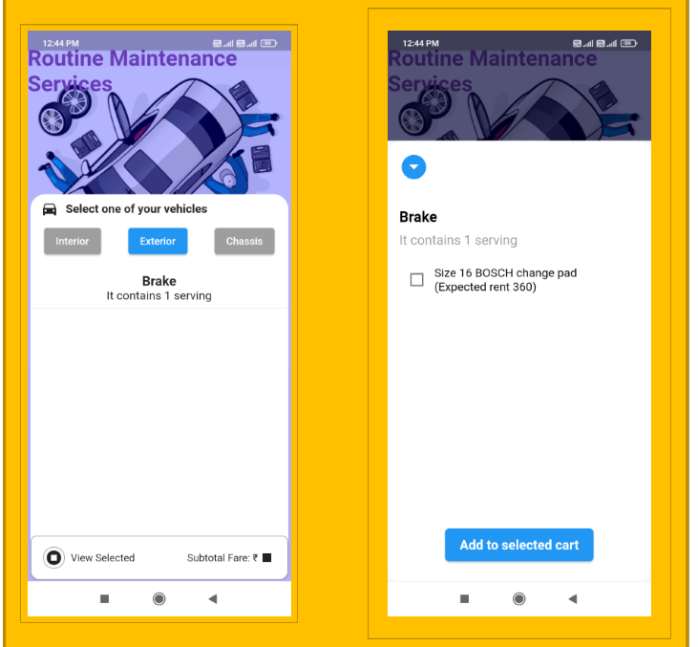

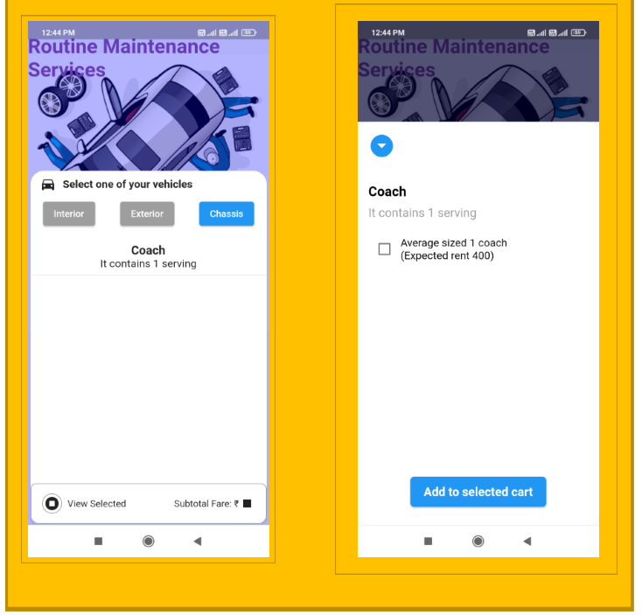

### Figure 5.3.2 App Interface & Features

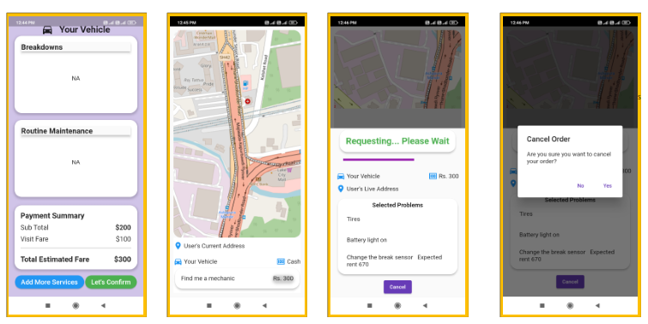

### Figure 5.3.3 App Interface & Features

### 

### Figure 5.4.1 Firebase Authentication

### Figure 5.4..2 Firebase Database

### 

### Figure 5.4.3 Furebase Storage

# Chapter 6 Conclusion and Future Scope

### Conclusion :

The "Mech !t" app is a significant milestone in the quest to revolutionize the way users find automotive assistance while safeguarding user privacy. With an impeccable user experience and privacy focus, it has not only met but exceeded expectations during testing.

The app's effectiveness and the positive user feedback received during testing underscore its potential to redefine how users seek automotive assistance. Its innovative privacy measures have set a high standard, addressing one of the most pressing issues in the industry.

### Future Scope :

The future of the "Mech !t" app is brimming with opportunities and innovation. Here are some key points to further enrich its scope:

1. **Smart Vehicle Integration**:

Explore the integration of the app with modern smart vehicles. This could enable users to receive real-time diagnostic data from their vehicles, allowing mechanics to pinpoint issues more accurately and expedite assistance.

1. **AI-Driven Predictive Maintenance**:

Develop an AI-based feature that predicts vehicle maintenance needs. This can alert users to upcoming service requirements, helping them stay proactive about their vehicle's health.

1. **Emergency Services**:

Extend the app's capabilities to provide emergency roadside services, including towing, tire changes & jump-starts. This widens app's utility & provides assistance during critical situations.

1. **In-App Parts Store**:

Consider incorporating an in-app store for automotive parts and accessories. Users can conveniently purchase necessary items through the app, enhancing their overall experience.

1. **User Education Hub**:

Create a section within the app dedicated to educating users about vehicle maintenance, safety, and DIY solutions. Informed users are likely to make better decisions about their vehicles and service providers.

1. **Virtual Mechanic Consultations**:

Introduce a feature that allows users to consult with mechanics virtually. Mechanics can assess minor issues and guide users on potential solutions without physical visits.

1. **Sustainability Initiatives**:

Promote eco-friendly automotive practices by encouraging the use of electric vehicles and providing information about sustainable driving habits.

1. **Data Analytics for Mechanics**:

Implement data analytics tools for mechanics, helping them analyze user preferences, common issues & trends. This data can assist mechanics in tailoring their services to user needs.

1. **User Rewards and Loyalty Programs**:

Institute loyalty programs and rewards for frequent users. This incentivizes users to stick with "Mech !t" for their automotive needs.

1. **Blockchain for Transparency**:

Consider integrating blockchain technology to ensure transparent and secure transactions. Users can have complete visibility into payments and transactions, fostering trust.

1. **Voice and Gesture Controls**:

Embrace emerging technologies like voice and gesture controls for hands-free app interaction, improving safety while using the app in vehicles.

1. **Collaborations with Auto Manufacturers**:

Collaborate with automobile manufacturers to provide exclusive services or offers to their vehicle owners through the app.

These additions will propel "Mech !t" into the future, making it an all-encompassing automotive companion that caters to wide array of user needs & keeps pace with evolving industry trends. The app's adaptability & continuous improvement will solidify its place as leader in automotive service sector.

# References

1. Smith, J., “Enhancing Roadside Assistance: A Study on Mobile Application Slutions”, May 2020
2. Patel, A., & Gupta, S., “Real-time Assistance Apps in Automotive: Current Trends and Future Directions”, February 2019
3. Wang, L., et al., “Privacy and Security in Mobile Applications A Comprehensive Review”, June 2018
4. Anderson, M., “Community Building in Mobile Apps: Strategies and Implications”, October 2019
5. Lee, K., et al., “Scalability in Mobile App Development: Challenges and Solutions”, July 2020
6. Github:

<https://github.com/sherif17/customer_app/tree/main>

<https://github.com/sherif17/mechanic_app>

<https://github.com/sherif17/winch_app>